**Directions to The Wendy House Barn Conversion (DO NOT DRIVE TO TAPNELL FARM)**

**Please do not drive to Tapnell Farm. The Wendy House has a separate entrance on the other side of the farm off of Broad Lane. You cannot get there via the farm.**

**From Wightlink Yarmouth:**

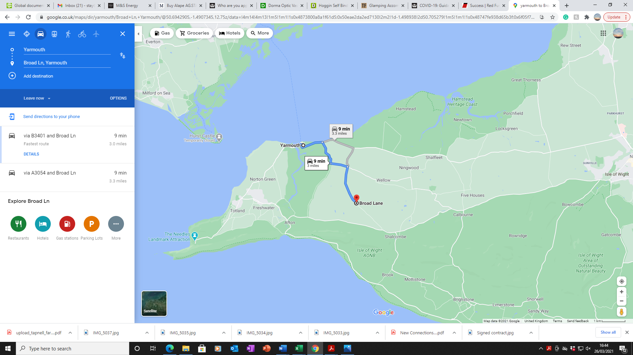

1. Leave the Wightlink Ferry

2. At the roundabout, take the 1st exit onto River Rd/A3054 (signed Newport)

3. After 0.7 miles, Turn right onto Thorley Rd/B3401 (signed Thorley)

4. After 0.7 miles, Turn left onto Newport Street/B3401

5. After 0.5 miles, Turn right onto Broad Lane

6. After about 1 mile, you’ll see the turning to The Wendy House on the right hand side.

7. The house has a long driveway and plenty of parking right outside. Please make yourself at home!

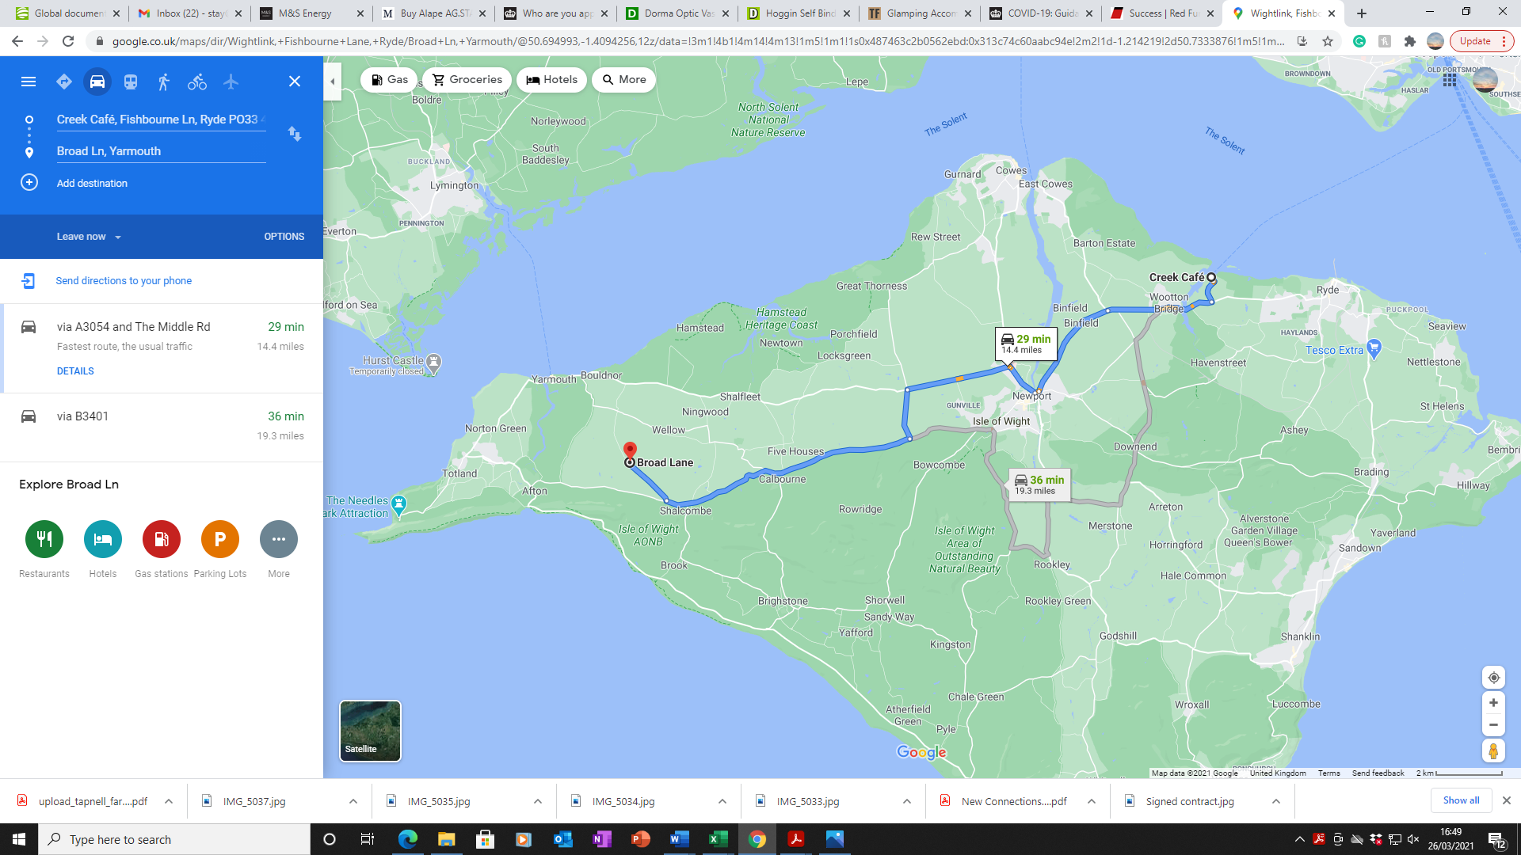**From Wightlink Fishbourne:**

1. Heading out of Wightlink Ferry port head right along Fishbourne Ln. Until you reach traffic lights at Junction.

2. Turn right at Traffic Lights – signposted Newport, Cowes, Yarmouth, Freshwater. This is the A3054.

3. Carry along this road for a couple of minutes. Cross the bridge in Wotton, past the ‘Sloop Inn’ on your right and keep going. Watch out for speed cameras!

4. Continue up Wotton high street and at next junction traffic lights continue over, past ‘The Cedars’ pub on your left – signposted Newport A3054.

5. Continue on this road until you reach a large roundabout. Keep left, sign posted Newport. Take the first exit.

6. Continue along the A3054 for a couple more minutes, past Medina High school on your right. Keep going.

7. At the traffic light junction continue across with ‘Seaclose stores’ on your left.

8. Past the church on your right. When the lane divides into to, take the right hand lane and at the next traffic lights turn right (this skips Newport town Centre)

9. Then after a few hundred meters turn right again (signposted Cowes, Yarmouth) onto the dual carriage way A3020. Keep in the left hand lane.

10. At the first set of traffic lights, continue straight on, then at the next set, verge into the left lane that turns round to the left- ‘Yarmouth, Freshwater A3053’. Carry on round, you are now on ‘Forest Road’.

11. Carry on over zebra crossings, past the school on your left.

Carry on along this road until you get to the traffic lights.

12. Carry on over at the traffic lights, and go a couple of hundred meters past the BMW Garage on the left. You will see a cross roads, sign posted right to ‘Porchfield’ or left with a size restriction symbol. Turn left. You are now on ‘Betty Haunt Lane’

13. Travel along the lane with care and at the end of the lane take the right hand fork (you will see the Blacksmiths arms (to your left) Turn right onto the road.

14. You are now on ‘The Middle Road’ B3051. Travel along here for about 10/15 minutes. You will pass Calbourne with its garage and Sun Inn (not the good one) on the right, down past Calbourne Mill on the right. Carry along and eventually you will pass Chessell pottery on the left, and keep going.

15. When you reach a dip in the road and two cottages on your right, turn right down ‘Broad Lane’ towards Yarmouth

16. A couple of miles down here you’ll see a turning on the left for ‘The Wendy House’ (the next turning on the left after ‘Dome Meadow’. You have arrived!

17. There is plenty of parking outside the house- please make yourself at home!

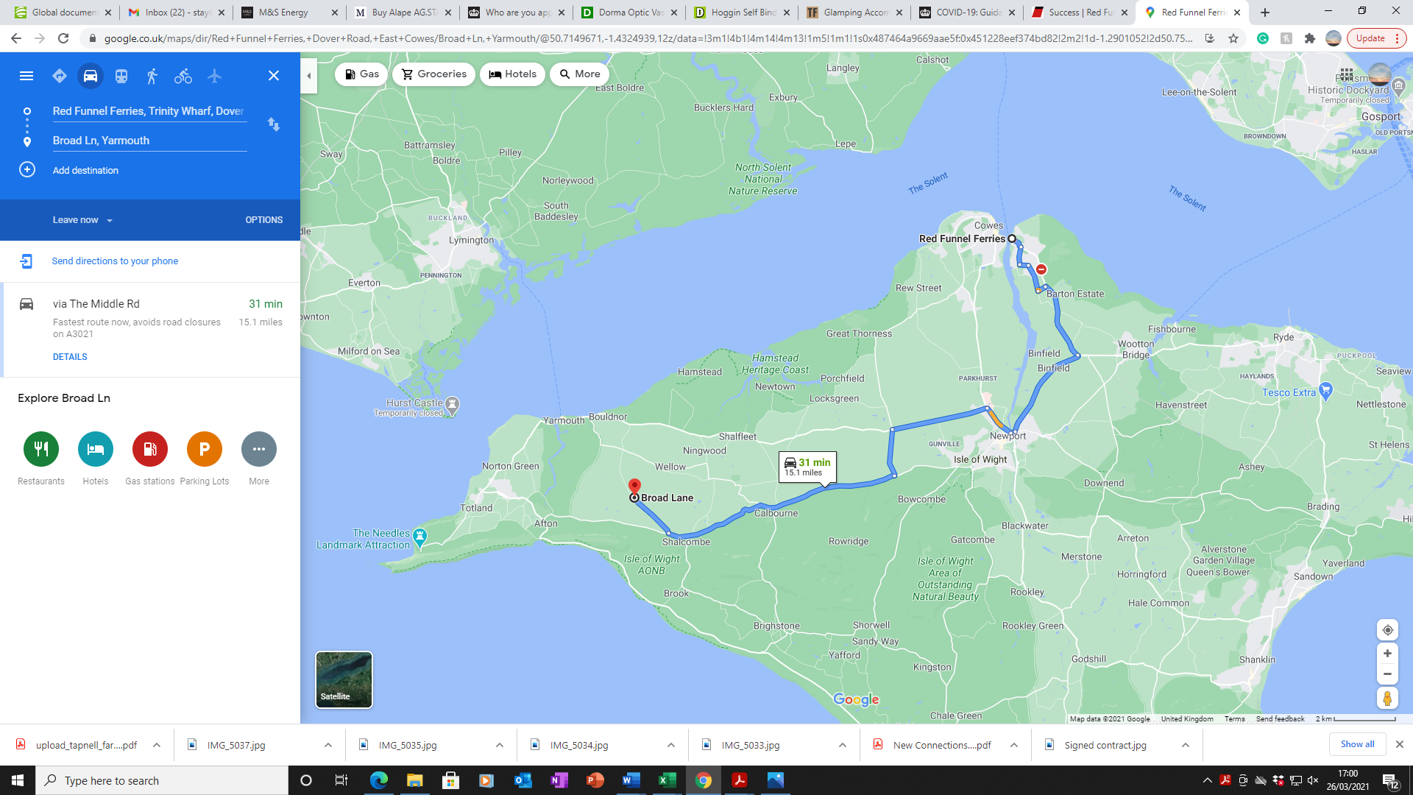**From Red Funnel East Cowes:**

1. Off of the ferry turn immediately left onto ‘Dover Road’

2. Go straight over the mini roundabout with Waitrose on your left. This is ‘Well Road’. Travel along Well road, through the traffic lights for a few minutes. The road becomes ‘York Avenue’.

3. Travel along York Ave. with a garage on your left then up past a tree lined park on your right.

4. Keep going, keep going along this road, you will pass ‘Albert Cottage’ on your left (this belonged to Queen Victoria’s Osbourne House Estate) Just keep going round and you will pass the entrance to Osbourne House (English Heritage, well worth a visit if you have time)

5. The road will now become Whippingham Road. You will come to a roundabout. Take the first exit – Signed Newport A3045. Carry along this road for a couple of minutes.

6. When you reach the large roundabout take the 2nd Exit signed Newport A3054.

7. Continue along the A3054 for a couple of minutes, past Medina Highschool on your right. Keep going.

8. At the traffic light junction continue across with ‘Seaclose stores’ on your left.

9. Past the church on your right. When the lane divides into to, take the right hand lane and at the next traffic lights turn right (this skips Newport town Centre)

10. Then after a few hundred meters turn right again (signposted Cowes, Yarmouth) onto the duel carriage way A3020. Keep in the left hand lane.

11. At the roundabout, take the first exit signposted ‘Yarmouth, Freshwater A3053’. Stay on this road, do not turn immediately left. Carry on round, you are now on ‘Forest Road’.

12. Carry on over zebra crossings, past the school on your left, and past ‘Parkhurst prison’ on your right. Carry on along this road until you get to the traffic lights.

13. Carry on over at the traffic lights, and go a couple of hundred meters past the BMW Garage on the left. You will see a cross roads, sign posted right to ‘Porchfield’ or left with a size restriction symbol. Turn left. You are now on ‘Betty Haunt Lane’

14. Travel along the lane with care and at the end of the lane take the right hand fork (you will see the Blacksmiths arms (to your left) Turn right onto the road.

15. You are now on ‘The Middle Road’ B3051. Travel along here for about 10/15 minutes. You will pass Calbourne with its garage and Sun Inn (not the good one) on the right, down past Calbourne Mill on the right. Carry along and eventually you will pass Chessell pottery on the left, and keep going.

16. When you reach a dip in the road and two cottages on your right, turn right down ‘Broad Lane’ towards Yarmouth

17. A couple of miles down here you’ll see a turning on the left for ‘The Wendy House’ (the next turning on the left after ‘Dome Meadow’. You have arrived!

18. There is plenty of parking outside the house- please make yourself at home!

**If you are traveling to the Island by foot – you might want to get a Taxi to the house.**

**We recommend:**

Jay’s Taxi’s - 07917 173865

Norton Taxi’s - 01983 759955

Alphpa Taxi - 0800 298 5421

**There is a bus service throughout the summer months that comes to the main farm, as well as Newport and Yarmouth. Please get in touch to find out more.**